1. Euler's Constant = 2.718281828
2. **Vmpp (Voltage at Maximum Power Point)**: The voltage at which a PV module (or string) produces its maximum power.

**Voc (Open-Circuit Voltage)**: The maximum voltage produced by a PV module (or string) when no current is drawn (open circuit).

**Impp (Current at Maximum Power Point)**: The current at which a PV module (or string) produces its maximum power.

**Isc (Short-Circuit Current)**: The maximum current produced by a PV module (or string) when its terminals are shorted.

**Temperature Coefficients (µ)**: These coefficients (e.g., µVoc, µPmax, µIsc) describe how the electrical parameters of a PV module change with temperature, typically expressed as %/°C.

**Important**: Voc and Vmpp *decrease* with increasing temperature (negative coefficient). Isc *increases* slightly with increasing temperature (positive coefficient).

1. Stores empirical coefficients (a, b, delta_tcnd(Δ tcnd)) for the module temperature model.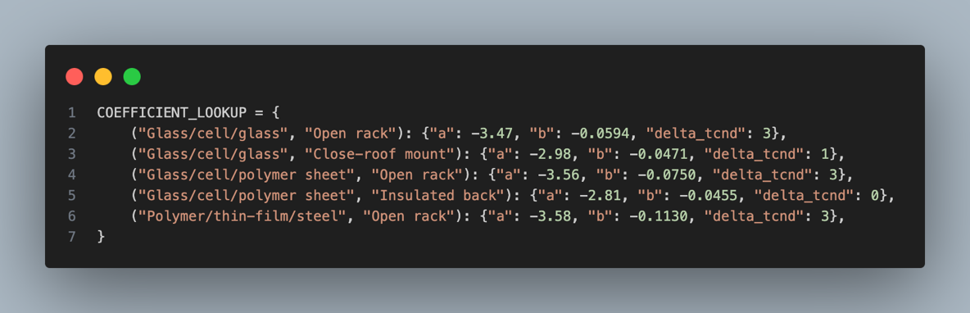
2. **Predict the module (Tm) and actual PV cell (Tcell) temperatures**.

This function is called repeatedly to derive the max_op_temp_c and min_op_temp_c.

* gain: max_temp_inclination_gain or min_temp_inclination_gain from user
* 'GHI', 'TEMP', 'WS': from uploaded excel file

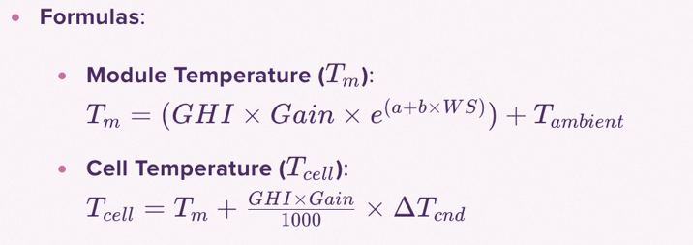

* 1. **max_op_temp_c**
* The uploaded environmental data is sorted by TEMP (Ambient Temperature) in **descending** order.
* The **top 20 rows** (representing the hottest ambient periods) are selected.
* For each of these 20 rows, Tcell is calculated using the calculate_tcell_for_row_internal function with the max_temp_inclination_gain
* The **absolute maximum Tcell** from these 20 calculations is chosen as max_op_temp_c.

* 1. **min_op_temp_c (Minimum Operating Cell Temperature)**
* **Scenario 1**: Data where GHI is **exactly equal** to ghi_filter_value.
* **Scenario 2**: Data where GHI is **greater than or equal to** ghi_filter_value
* It's sorted by TEMP (Ambient Temperature) in **ascending** order.
* The single row with the lowest ambient temperature is selected.
* Tcell is calculated for this row using calculate_tcell_for_row_internal with the min_temp_inclination_gain.
* From the Tcell values calculated for both scenarios, the **absolute minimum Tcell** is chosen as min_op_temp_c.

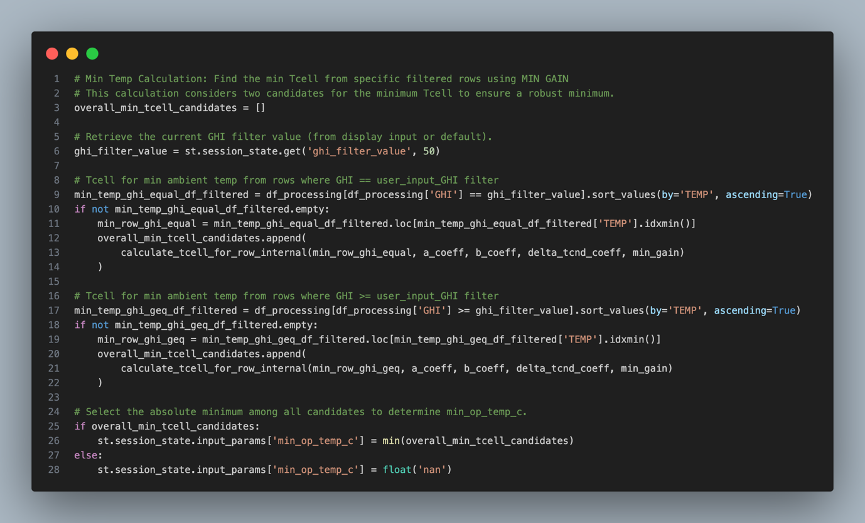

1. **Design Configuration:**

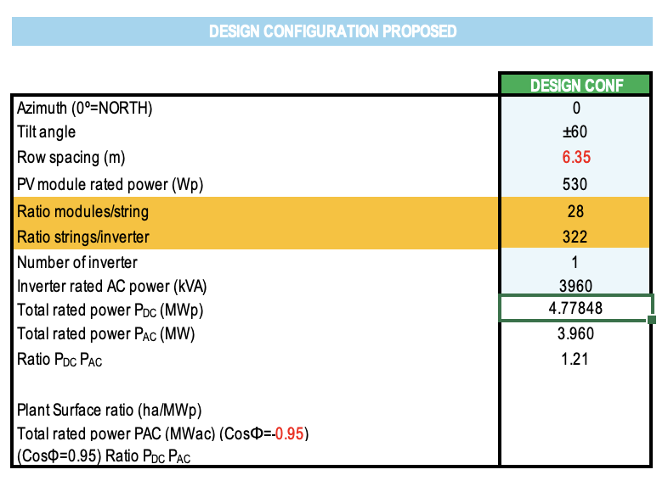

Calculation for Total rated Power P(DC) & P(AC)

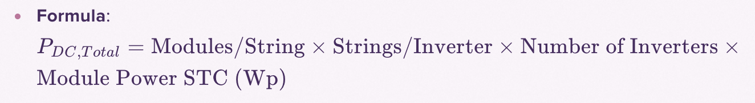

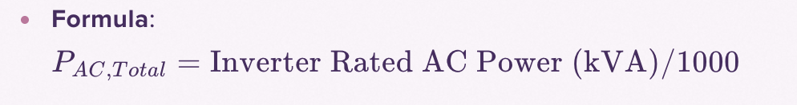

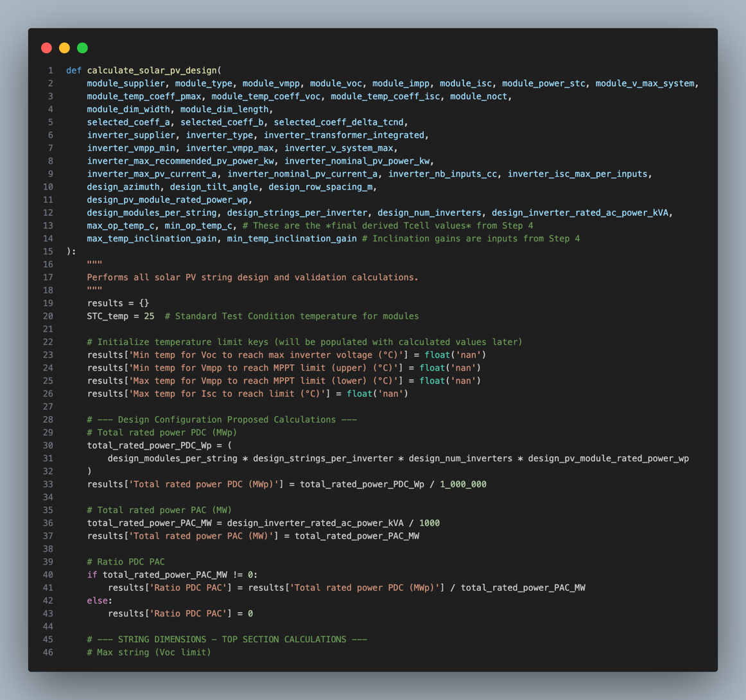

1. **String Dimensions Calculations**

These calculations establish the theoretical minimum and maximum number of modules per string and strings per MPPT input to comply with inverter specifications at STC.

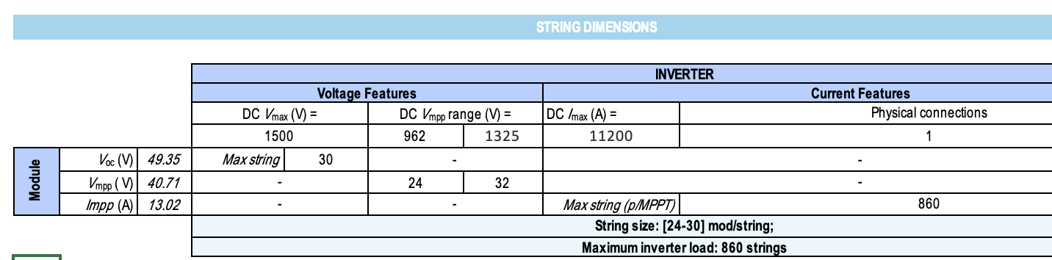

* **Max string (Voc_limit_calc):** *(Calculation for the value we got 30)*

To find the maximum number of modules you can put in a series string without exceeding the inverter's maximum DC input voltage

* **Min string (Vmpp_min_limit_calc):** *(Value 24)*

To find the minimum number of modules per string such that the string's maximum power point voltage (Vmpp) is always above the inverter's minimum MPPT voltage.

* **Max string (Vmpp_max_limit_calc)**: *(value 32)*

To find the maximum number of modules per string such that the string's Vmpp is always below the inverter's maximum MPPT voltage (inverter_vmpp_max)

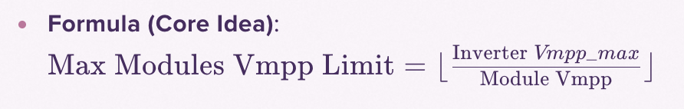

* **Max string (p/MPPT)_limit_calc**: (value 860)

**

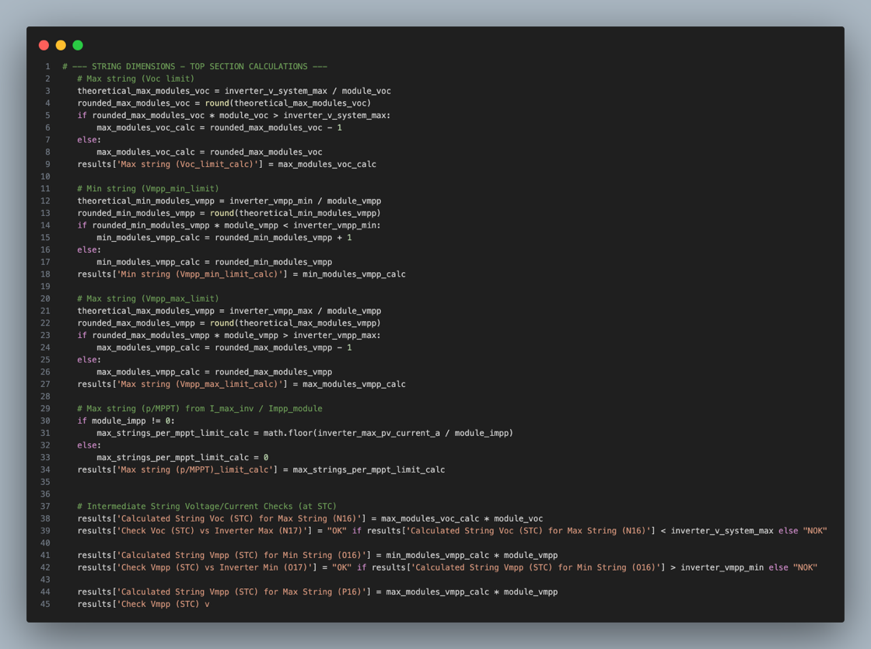

1. **Intermediate String Voltage/Current Checks**

These are basic checks to quickly validate the string's electrical parameters at Standard Test Conditions against the inverter's capabilities.

* **Calculated String Voc (STC) for Max String**: max_modules_voc_calc * module_voc
* **Check Voc (STC) vs Inverter Max**: Checks if the above calculated Voc is less than inverter_v_system_max.
* **Calculated String Vmpp (STC) for Min String**: min_modules_vmpp_calc * module_vmpp
* **Check Vmpp (STC) vs Inverter Min**: Checks if the above calculated Vmpp is greater than inverter_vmpp_min.
* **Calculated String Vmpp (STC) for Max String**: max_modules_vmpp_calc * module_vmpp
* **Check Vmpp (STC) vs Inverter Max**: Checks if the above calculated Vmpp is less than inverter_vmpp_max. **A black screen with white text

  AI-generated content may be incorrect.**

1. **Configuration Maximum (Check against Recommended Inverter Power)**

This confirms if the proposed array size connected to a single inverter is within the inverter manufacturer's recommendation.



* **Configured_DC_Power_per_inverter_kWp**: *(Value 4778.48)*

Calculates the actual DC power (at STC) that the user's proposed configuration will deliver to each inverter.



* **Check_Config_DC_Power**:

Verifies if the calculated Configured_DC_Power_per_inverter_kWp is less than or equal to the inverter's inverter_max_recommended_pv_power_kw.

1. **Temperature Behaviour Calculations**

Calculations that adjust module/string electrical characteristics based on the derived operating cell temperatures (max_op_temp_c and min_op_temp_c).

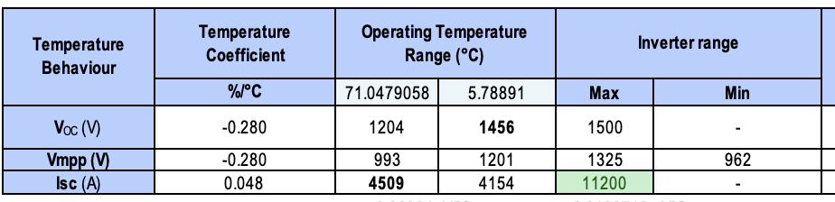

* **String Voc (V) at Max Op Temp**: *(Value 1204)*
* modules/string* module_voc * (1 + (module_temp_coeff_voc * temp_diff_max_op / 100))
* temp_diff_max_op = max_op_temp_c - STC_temp(25)
* **String Vmpp (V) at Max Op Temp**:
* design_modules_per_string * module_vmpp * (1 + (module_temp_coeff_voc * temp_diff_max_op / 100))
* **Isc (A) at Max Op Temp**:

design_strings_per_inverter * module_isc * (1 + (module_temp_coeff_isc * temp_diff_max_op / 100))

1. **Additional Intermediate Calculations**

* **string_voc_change_per_degC**: *(value -3.86904)*

The absolute change in string Voc per 1°C temperature change.

* **temp_diff_max_op_exact**: max_op_temp_c - STC_temp.
* **total_voc_change_max_temp**:

**Purpose**: Total voltage change from STC to max_op_temp_c.

**Formula**: temp_diff_max_op_exact * string_voc_change_per_degC

* **string_voc_stc**:

**Formula**: module_voc * design_modules_per_string

* **array_current_change_per_degC**:

Absolute change in array current (using Impp) per 1°C temperature change.

* **array_impp_stc**:

module_impp * design_strings_per_inverter

* **total_current_change_max_temp**:

The remaining current "headroom" in the inverter's maximum current rating relative to the array's STC Impp.

**Formula**: inverter_max_pv_current_a - array_impp_stc

* **array_impp_at_max_op_temp**:

Array Impp adjusted for maximum operating temperature.

array_impp_stc + (temp_diff_max_op_exact * array_current_change_per_degC)

1. **Temperature Limits for Compliance**

* **Min temp for Voc to reach max inverter voltage (°C)**:

The lowest ambient temperature at which the string's Voc would theoretically reach the inverter's maximum system voltage (inverter_v_system_max). This is a critical cold-weather over-voltage risk indicator.

* **Min temp for Vmpp to reach MPPT limit (upper) (°C)**:

The lowest ambient temperature at which the string's Vmpp would theoretically reach the inverter's maximum MPPT voltage (inverter_vmpp_max).

* **Max temp for Vmpp to reach MPPT limit (lower) (°C)**:

The highest ambient temperature at which the string's Vmpp would theoretically drop to the inverter's minimum MPPT voltage (inverter_vmpp_min). This is a critical hot-weather under-voltage risk indicator, where the inverter might stop operating efficiently.

* **Max temp for Isc to reach limit (°C)**:

The increase in temperature (from STC) required for the array's short-circuit current to reach the inverter's maximum current limit.

This value represents the temperature difference from STC at which the limit would be reached, not the absolute temperature. If positive, it means the current would exceed the limit at temperatures above STC by that amount. If negative, it means the limit would be exceeded at temperatures below STC

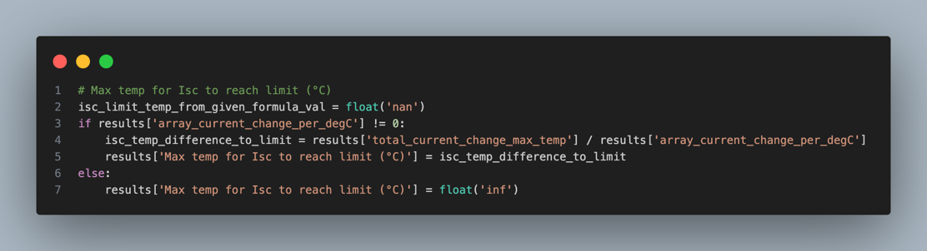

1. **Compliance Checks and Comments**

These are logical checks that compare the calculated operating values against the inverter and module specifications.

* **Check: Voc Compliance**:
* Checks if the calculated String Voc (V) at both max_op_temp_c and min_op_temp_c (coldest being highest Voc) respects:
* inverter_v_system_max (inverter's absolute max input voltage).
* module_v_max_system (module's absolute max system voltage).
* If any of these conditions are violated, the status becomes "NOK" with an appropriate comment. Otherwise, "OK".
* **Check: Vmpp Compliance**:

Checks if the calculated String Vmpp (V) at both max_op_temp_c (hottest being lowest Vmpp) and min_op_temp_c (coldest being highest Vmpp) stays within:

* inverter_vmpp_min (string Vmpp must be >= this value).
* inverter_vmpp_max (string Vmpp must be <= this value).
* module_v_max_system (module's absolute max system voltage).
* If any of these conditions are violated, the status becomes "NOK" with an appropriate comment. Otherwise, "OK".
* **Check: Isc Compliance**:

Checks if the calculated Array Isc (A) at both max_op_temp_c (hottest being higher Isc) and min_op_temp_c (coldest being lower Isc) respects:

* inverter_max_pv_current_a (inverter's absolute max input current).

If any of these conditions are violated, the status becomes "NOK" with an appropriate comment. Otherwise, "OK".

